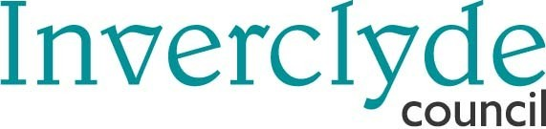
Municipal Buildings, Greenock PA15 1LY
Ref: SL/AI
Date: 5 September 2018
I refer to the meeting of the Education & Communities Committee held on Tuesday 4 September 2018 and attach report as undernoted which the Committee agreed to consider as an additional item.

GERARD MALONE
Head of Legal and Property Services

UNDERNOTE

Additional Item:

Emergency Services Day – 999 Day – 9 September
Report by Head of Organisational Development, Policy & Communications
Enquiries to - Sharon Lang - Tel 01475 712112

